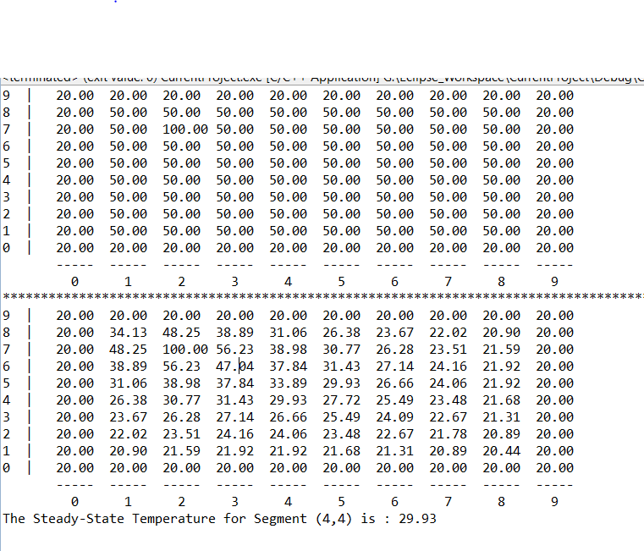

>>This shows result of running the program once, the metal plate is initialized with values and is printed to the screen. Then an algorithm is run several times (86 in this case) to distribute the heat around the plate until the change before and after is less than .01 degrees.